**JDK installation:**

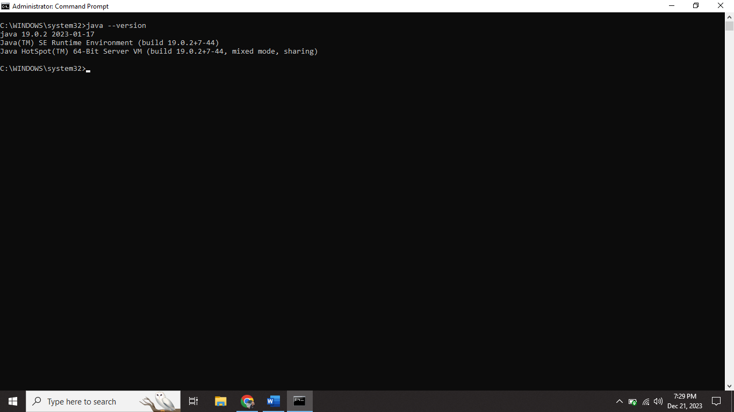

**Python installation:**

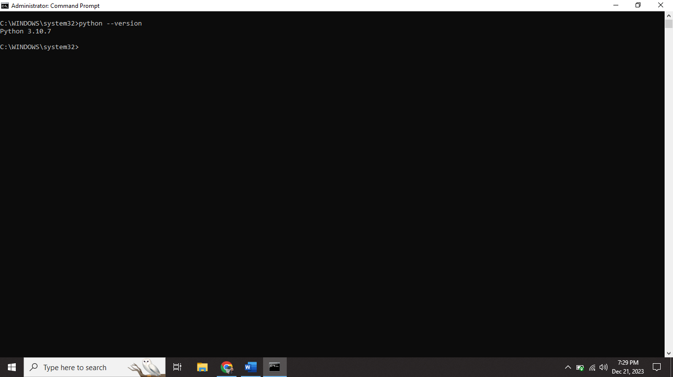

**Spark File download and extracted:**

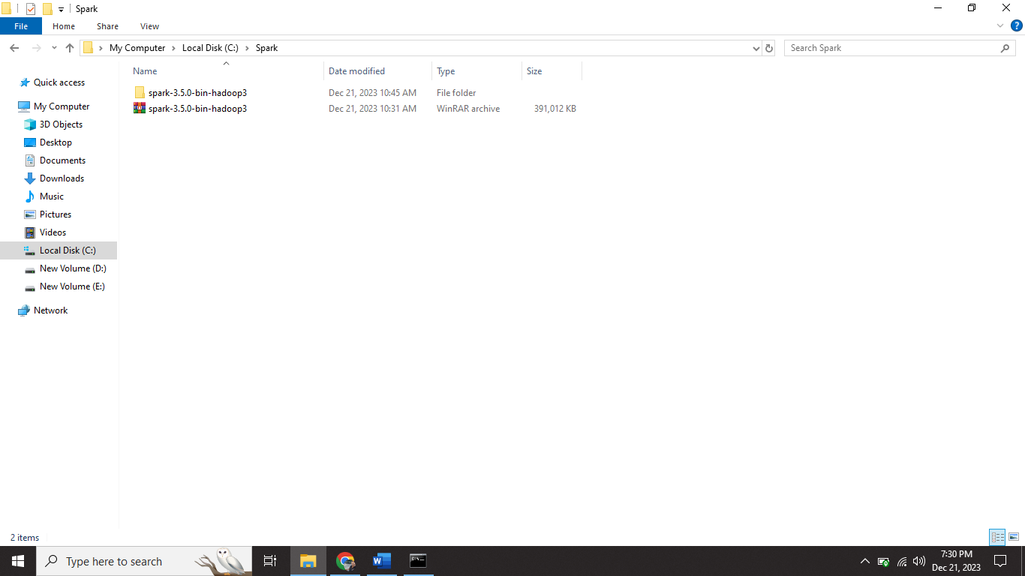

**Environmental variable setup:**

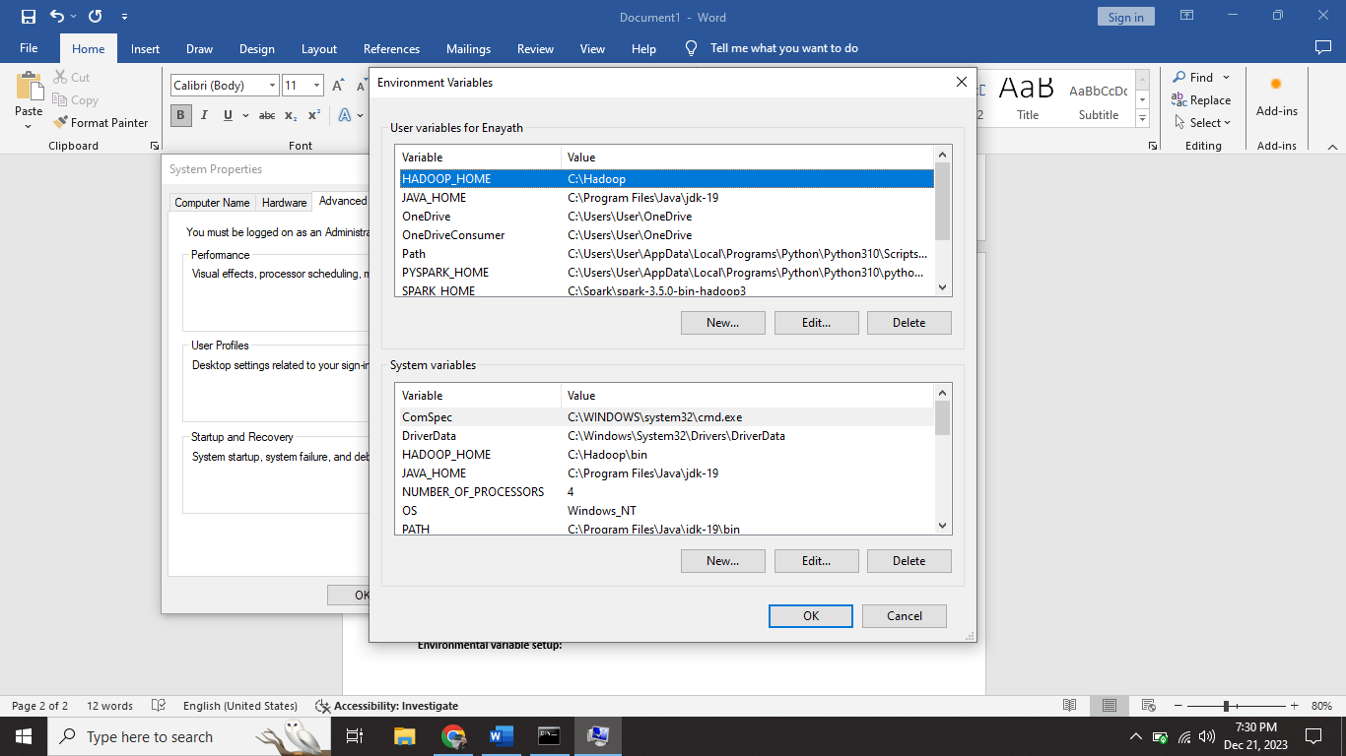

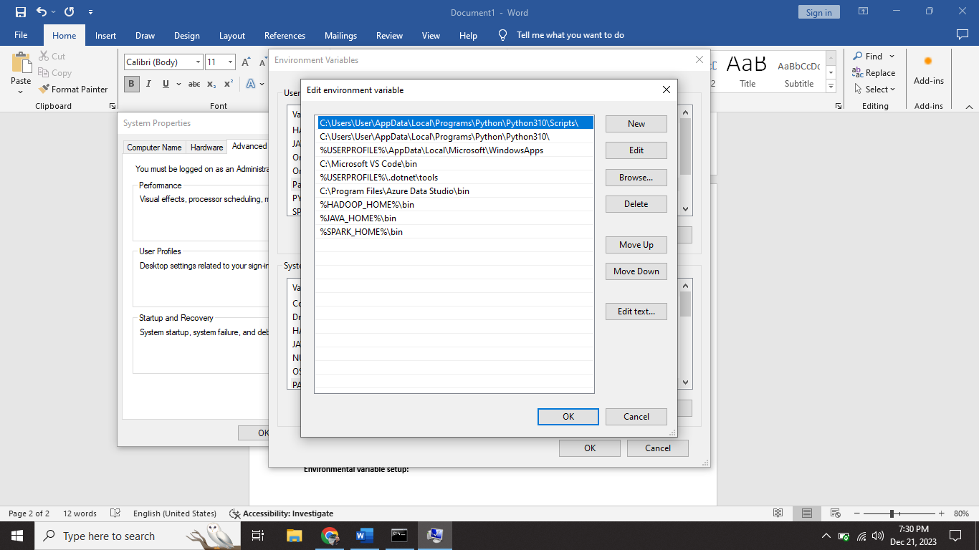

**Pyspark installation:**

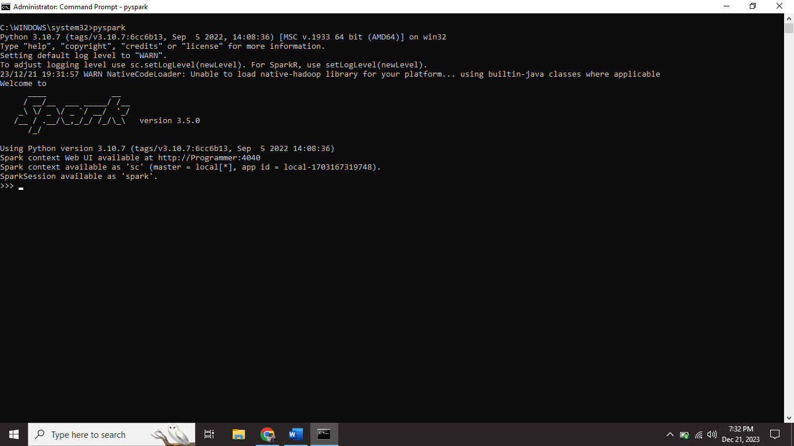

**Pyspark webpage view:**

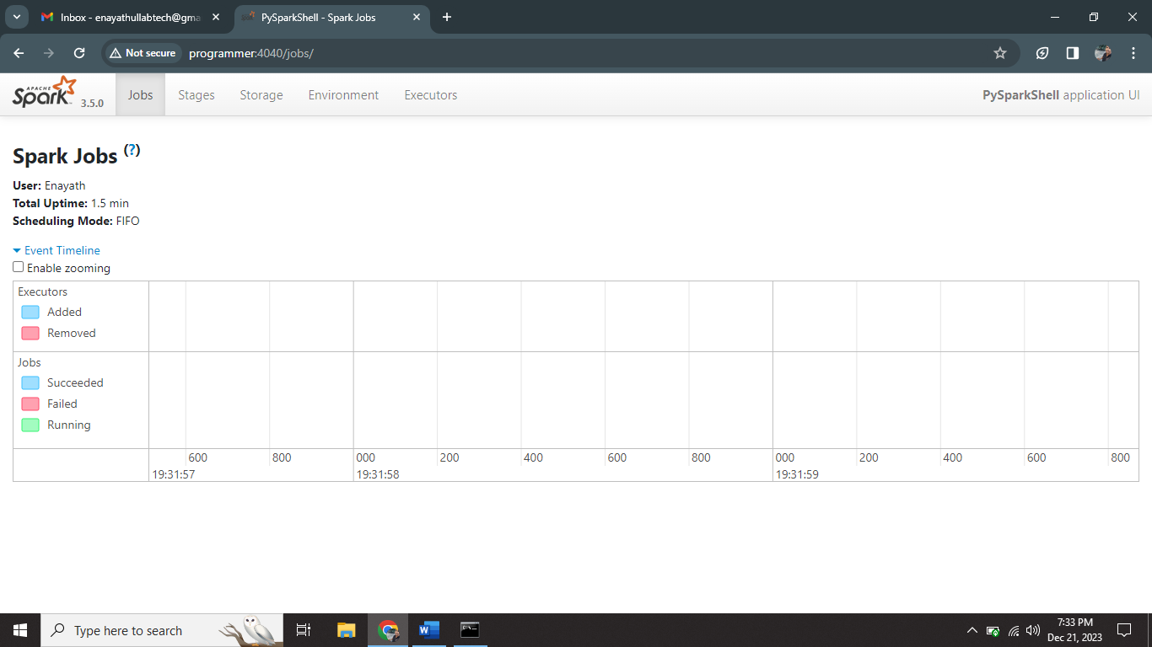

**I successfully installed jdk, spark, Hadoop, pyspark and setup all needed environmental variables.**